**Q1:**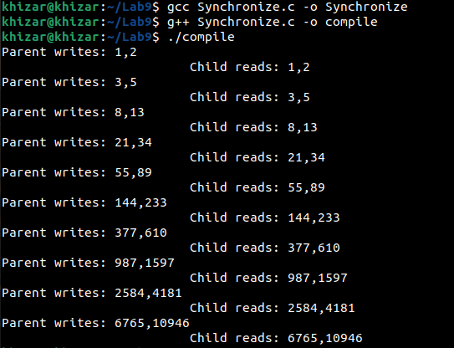In this task the parent process is writing and the child process is reading the values. And both of the processes are synchronized. When the parent writes something, it waits for the child to read that and then the parent writes the next data.

**Q2:**

1. If sleep(1) for parent and child.

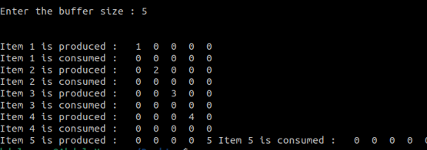

In this part the producer and consumer both are doing their tasks with the delay of 1 second.

1. If sleep(2) for parent and sleep(1) for child.

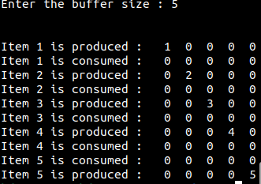

In this tasks the producer is going to sleep for 2 seconds and it doesn't affect the execution of the consumer.

1. If sleep(2) for parent and sleep(1) for child.

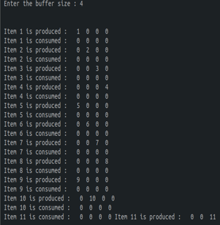

In this task the consumer is going to sleep for 2 seconds while the producer is on sleep for 1 second so the producer is producing 2 times and the consumer is consuming for 1 time in one execution.